Puppy Adoption Application  www.broadacresfarm.com  Broad Acres Farm  27929 NE 100th St, Carnation WA  broadacresfarm@gmail.com  phone: 206-366-5449 | 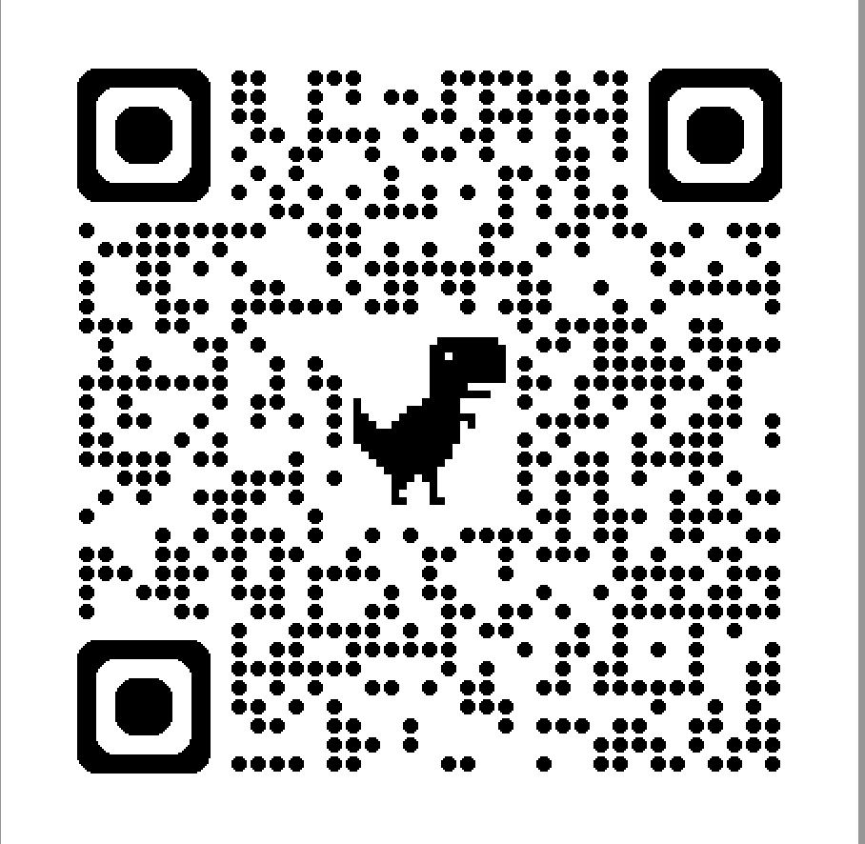

Adopters Name:
First: ____________________ Last :____________________

Adopter’s Address:
____________________________________
____________________________________
____________________________________

Phone: _____________________ Cell Phone: _____________________
Email: ___________________________
Driver’s License number: _____________________ State: ________

Do you rent or own: ________________________
Landlord’s name: First:____________________ Last :____________________
Landlord’s phone: ________________________

Do you have a fenced yard: ___________
Do you have any children: ___________ What ages:_________________
Have you previously owned a dog? _________
Do you own other pets? __________ Which: ____________________

REFERENCES

Reference 1 Name:
First: ____________________ Last :____________________

Cell Phone: _____________________ Email: _____________________

Reference 2 Name:
First: ____________________ Last :____________________

Cell Phone: _____________________ Email: _____________________

